CUSTOMER CHURN ANALYSIS
Predicting Customer Churn in the Banking Sector:
A Logistic Regression and SMOTE-Based Analysis
Student Name: Nikita Mishra
Northeastern University
Class: ALY6015: Intermediate Analytics, Section 31,
Instructor: Sohom Mandal
Date: May 14, 2026.

Abstract
Customer churn, the phenomenon of customers discontinuing their relationship with a service provider, poses a significant financial challenge for banking institutions. This report investigates the key determinants of customer churn at a European bank using a dataset of 10,000 customer records. Two analytical approaches were evaluated: binary logistic regression with threshold tuning and Synthetic Minority Oversampling Technique (SMOTE)-enhanced logistic regression. The dataset included demographic, geographic, and behavioral customer variables obtained from a publicly available bank customer churn dataset. Exploratory data analysis identified age, geographic location (particularly Germany), and member activity status as the strongest predictors of churn.
The baseline logistic regression model achieved an overall accuracy of 82.16% at the default classification threshold of 0.5; however, sensitivity for the minority churn class was limited to 23.1%. Lowering the classification threshold to 0.3 improved sensitivity to 51.9% while maintaining acceptable balanced accuracy and model stability. Although the SMOTE-enhanced model further increased sensitivity to 86.1%, it also substantially reduced specificity and overall accuracy due to increased false positives. The model produced an AUC of 0.7796, indicating good discriminatory performance. Overall, the threshold-tuned logistic regression model provided the best balance between churn detection capability and operational practicality. Findings suggest that banks should prioritize retention efforts for older customers, inactive members, and customers located in Germany.Keywords: customer churn, logistic regression, SMOTE, class imbalance, binary classification, banking

Introduction
Customer retention is a critical priority in the banking industry, as acquiring new customers is significantly more expensive than retaining existing ones (Reichheld & Schefter, 2000). Customer churn, defined as customers leaving a service provider, can reduce revenue, weaken customer relationships, and increase operational costs. Predicting churn before customers leave enables banks to implement proactive retention strategies and improve long-term profitability.
This project analyzes a dataset of 10,000 customers from a European banking institution to identify the key demographic, financial, and behavioral factors associated with customer churn. The dataset includes variables such as age, gender, geography, credit score, account balance, number of products, tenure, and customer activity status, along with a binary churn outcome variable.
Binary logistic regression was used as the primary predictive modeling technique due to its suitability for binary classification problems and interpretability. To improve churn detection performance, threshold tuning was applied by lowering the classification threshold from 0.5 to 0.3. SMOTE (Synthetic Minority Oversampling Technique) was also explored to address the dataset’s class imbalance, where churned customers represented approximately 20% of observations.
The goals of this project are to identify significant churn predictors, evaluate predictive model performance, and develop actionable business recommendations to support customer retention strategies.

Methods

Dataset
The dataset used in this analysis is a publicly available bank customer churn dataset (churn.xlsx) containing 10,000 observations and 14 variables. Each row represents a unique bank customer. Variables include RowNumber, CustomerId, Surname (excluded from modeling as non-predictive identifiers), CreditScore, Geography (France, Germany, Spain), Gender (Female, Male), Age, Tenure (years with the bank), Balance (account balance in euros), NumOfProducts (number of bank products used), HasCrCard (binary: owns a credit card), IsActiveMember (binary: active membership status), EstimatedSalary, and Exited (binary outcome: 1 = churned, 0 = retained).
Prior to modeling, the dataset was inspected for missing values and duplicate records. No missing values were detected across any of the 14 variables, and no duplicate rows were found. Categorical variables—Geography, Gender, Exited, HasCrCard, and IsActiveMember—were converted to factor variables in R to ensure correct handling in statistical modeling.

Method 1: Binary Logistic Regression

Binary logistic regression was selected as the primary predictive modeling technique because the target variable (Exited) is binary (0 = retained, 1 = churned), making logistic regression appropriate for estimating churn probability (Hosmer et al., 2013). The model was implemented using R’s glm() function with family = binomial.

Ten predictor variables were included in the model: CreditScore, Geography, Gender, Age, Tenure, Balance, NumOfProducts, HasCrCard, IsActiveMember, and EstimatedSalary. The dataset was divided into a 70% training set and a 30% testing set using stratified random sampling through the createDataPartition() function from the caret package. Multicollinearity was assessed using the Variance Inflation Factor (VIF), with all VIF values remaining well below the threshold of 5.

To improve churn detection performance, threshold tuning was applied by lowering the classification threshold from 0.5 to 0.3.

Method 2: SMOTE (Synthetic Minority Oversampling Technique)
Class imbalance is a well-documented challenge in churn prediction, where the majority class (retained customers) substantially outnumbers the minority class (churned customers). In the present dataset, 79.63% of customers are retained versus 20.37% who churned. When imbalanced data is used directly in logistic regression, the model tends to be biased toward predicting the majority class, resulting in low sensitivity for churn detection, which is precisely the class of greatest business interest (Chawla et al., 2002).
SMOTE addresses this problem by synthetically generating new minority-class observations through interpolation between existing minority-class samples and their k-nearest neighbors. In this analysis, SMOTE was applied using the smotefamily package in R with K = 5 nearest neighbors and dup_size = 2, producing a balanced training dataset of 9,853 observations (5,575 retained, 4,278 churned). The SMOTE-balanced training data was then used to train a second logistic regression model, which was evaluated on the original (non-SMOTE) test set to measure real-world performance improvement.

Model Evaluation
Model performance was evaluated using confusion matrices and classification metrics including accuracy, sensitivity (recall), specificity, precision, balanced accuracy, and Cohen’s Kappa. Because identifying churned customers was considered a key business objective, sensitivity was treated as an important evaluation metric. ROC curves and Area Under the Curve (AUC) values were also generated using the pROC package to evaluate overall discriminatory performance.

1-Analysis

1.1 Data Import and Cleaning
The dataset was imported into R using the readxl package. Inspection confirmed 10,000 rows and 14 columns, with no missing values and no duplicate records. Categorical variables were converted to R factor types to ensure correct treatment as categorical predictors in logistic regression.
Output: dim(churn): [1] 10000 14 | colSums(is.na(churn)): All variables = 0 | sum(duplicated(churn)): [1] 0 | Exited: 0: 7963, 1: 2037
Interpretation: The dataset is complete with no missing values or duplicate records, making it ready for analysis without imputation. The 14 variables cover a comprehensive set of customer demographics and behavioral attributes. Converting categorical variables to R factor types is a critical preparation step that prevents logistic regression from treating them as continuous predictors.

1.2. Exploratory Data Analysis — Churn Distribution
Figure 1. Customer Churn Distribution Bar Chart
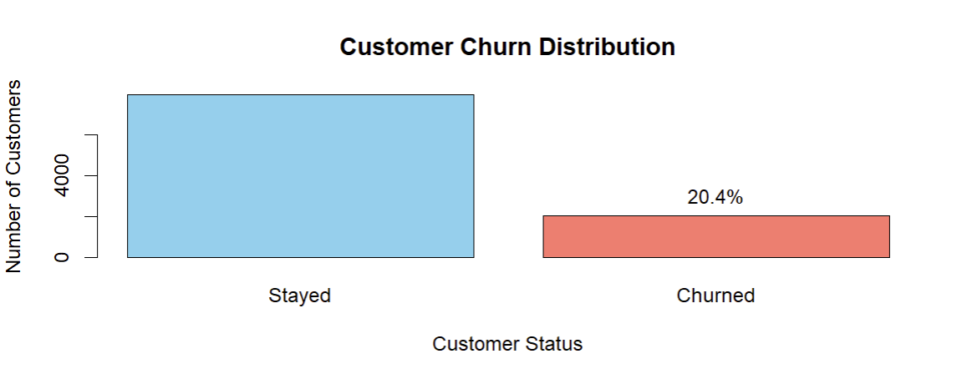
Output: Retained (0): 7,963 (79.63%) | Churned (1): 2,037 (20.37%)
Interpretation: The dataset shows a clear class imbalance, with roughly a 4:1 ratio between retained and churned customers. A model that naively predicts 'no churn' for every customer would achieve nearly 80% accuracy, highlighting why overall accuracy alone is an insufficient evaluation metric and why sensitivity for the churn class is the more meaningful performance measure.

1.3. Exploratory Data Analysis — Age vs. Churn
Figure 2. Age Distribution by Churn Status
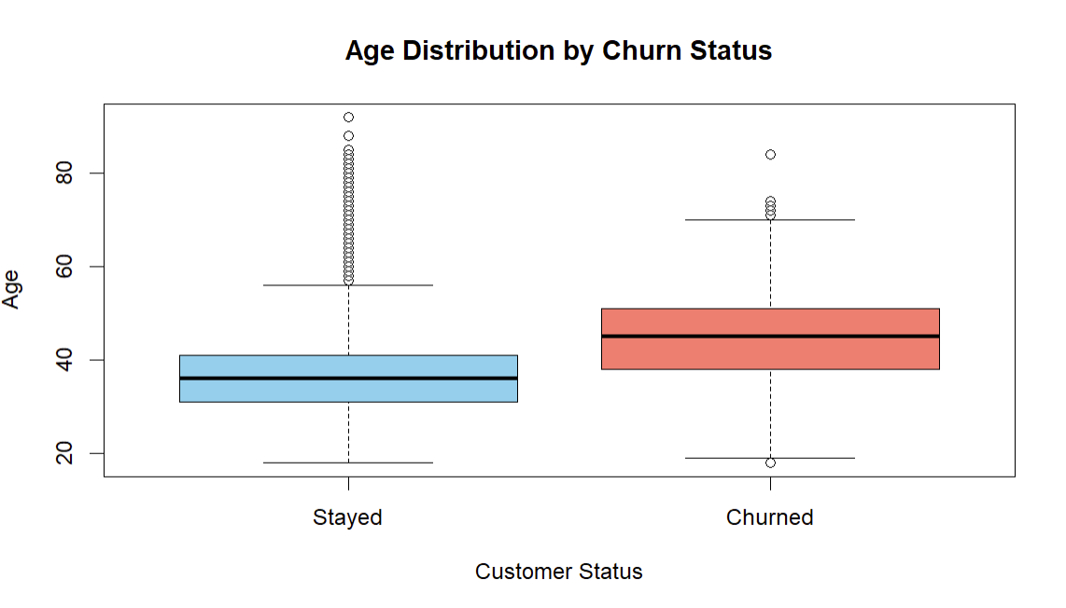
Interpretation: Churned customers exhibit a noticeably higher median age compared to retained customers. The interquartile range for churned customers spans approximately 35 to 55 years, compared to a narrower, younger distribution among retained customers. This suggests older customers may be less satisfied with digital banking services or more susceptible to competitor offers. Age is later confirmed as the dominant predictor in the logistic regression model, with the highest variable importance score (23.05).

1.4. Exploratory Data Analysis — Account Balance vs. Churn
Figure 3. Account Balance by Churn Status
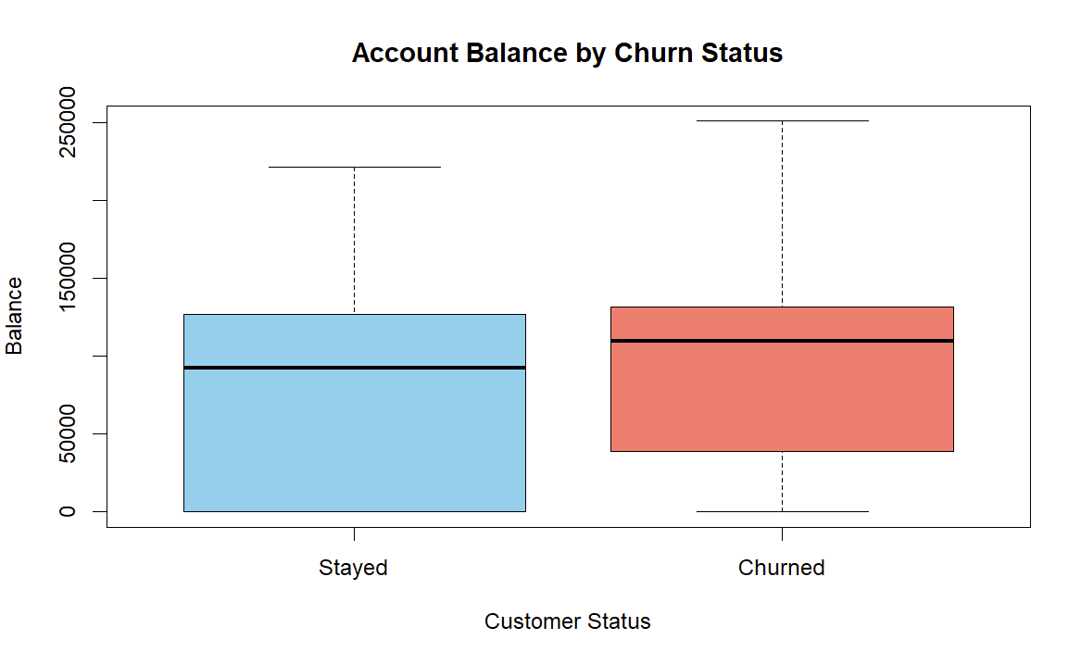
Interpretation: Churned customers tend to carry higher account balances than retained customers. While counterintuitive, this may suggest that high-balance customers are more financially aware and actively seeking better returns at competing institutions. The large number of zero-balance observations among retained customers further distinguishes the two groups. Balance is confirmed as a significant predictor (p < 0.001).

1.5. Exploratory Data Analysis — Geography vs. Churn
Figure 4. Churn Rate by Geography
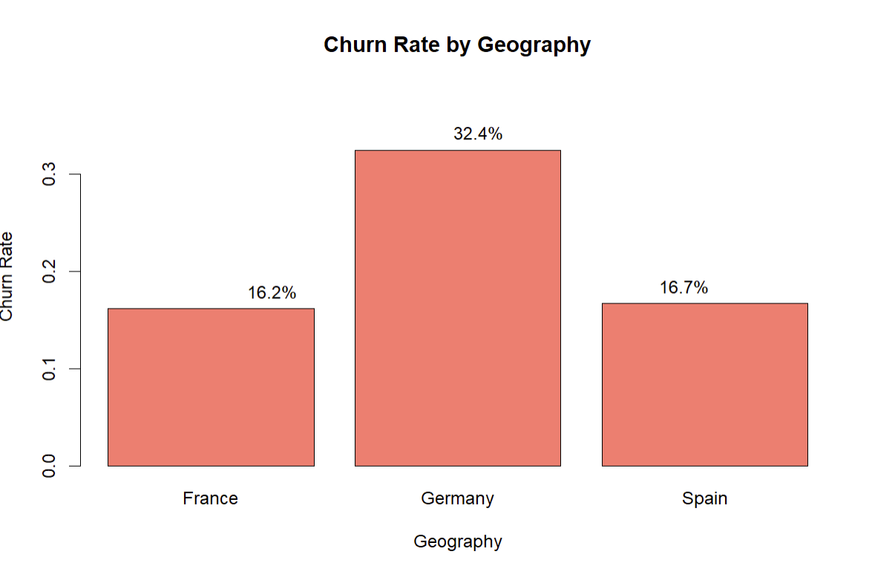
Output: France: 16.2% | Germany: 32.4% | Spain: 16.7%
Interpretation: Germany has a dramatically higher churn rate (32.4%) compared to France (16.2%) and Spain (16.7%), which are nearly identical. This regional disparity suggests country-specific factors, which is a local market competition, banking regulations, or service quality, which plays a meaningful role in retention. The logistic regression confirms Germany as a highly significant predictor (OR = 2.002, p < 0.001), meaning German customers are approximately twice as likely to churn as French customers when other factors are held constant.

1.6. Exploratory Data Analysis — Activity Status vs. Churn
Figure 5. Churn Rate by Customer Activity Status
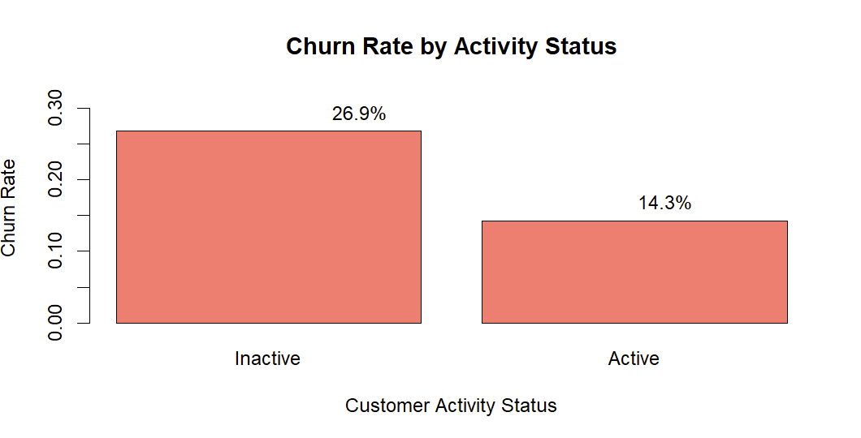
Interpretation: Inactive members show a substantially higher churn rate (~26.9%) than active members (~14.3%). Customers who are not actively engaging with the bank's products and services are more likely to eventually close their accounts or move to a competitor. The regression model confirms this, with an odds ratio of 0.330 for active members, meaning active membership reduces churn odds by approximately 67%.

1.7. Exploratory Data Analysis — Number of Products vs. Churn

Figure 6. Churn Rate by Number of Bank Products
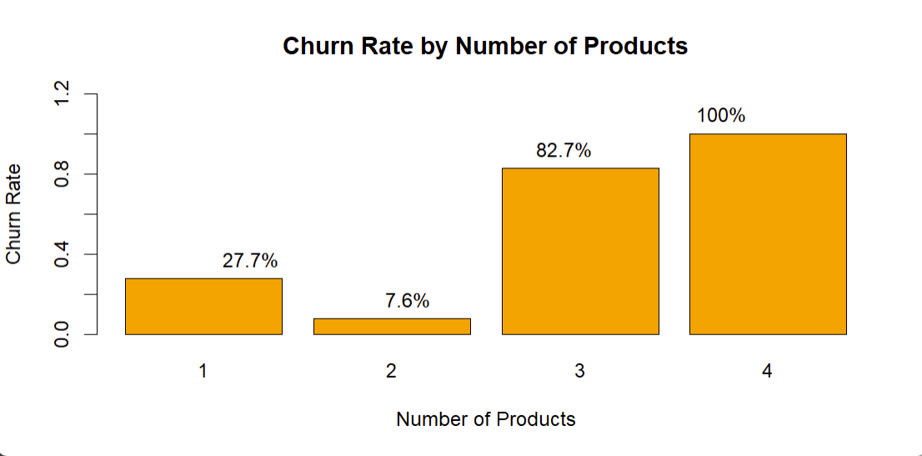
Interpretation: The churn rate by number of products follows a non-linear pattern. Customers holding one or two products have moderate churn rates, while those with three or four products exhibit extremely high churn rates, which in some cases approaching 80–100%. This counter-intuitive finding suggests that customers with multiple products may be over-extended or dissatisfied with bundled offerings. Simply increasing the number of products sold to a customer is therefore not a reliable retention strategy.

1.8. Correlation Analysis
Figure 7. Correlation Matrix Heatmap for Numeric Predictor Variables
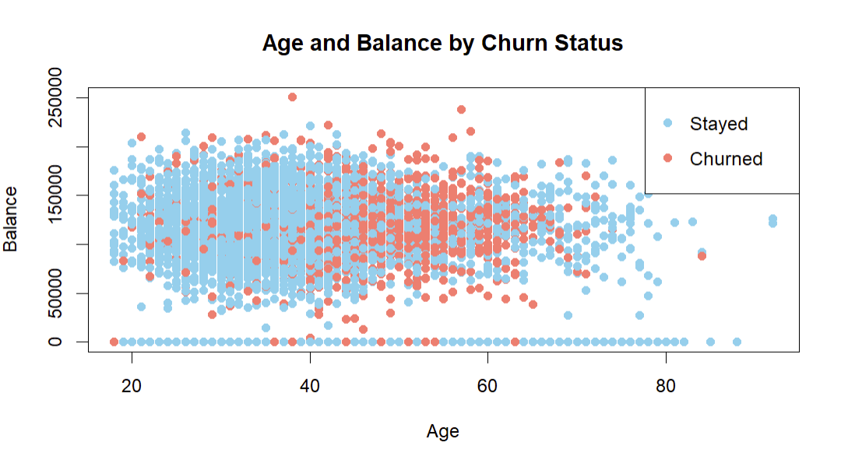
Interpretation: The correlation matrix reveals that the numeric predictor variables are largely uncorrelated with one another. No correlation coefficient approaches the conventional threshold of concern (|r| > 0.7), indicating that multicollinearity is not a significant issue. The subsequent VIF analysis (all values below 1.3) formally confirms this conclusion, and the low inter-predictor correlations suggest that each variable contributes relatively independent information to the model.

2-Train-Test Split

The dataset was divided into training and testing subsets using a 70:30 ratio through stratified random sampling with the createDataPartition() function from the caret package in R. A random seed value of 123 was set to ensure reproducibility of the results. Stratified sampling was specifically chosen to preserve the original class distribution of churned and retained customers in both subsets. The training dataset was used to build the logistic regression model, while the testing dataset was reserved for evaluating model performance on unseen data. This approach helps assess how well the model generalizes beyond the data used during training and reduces the risk of overfitting.
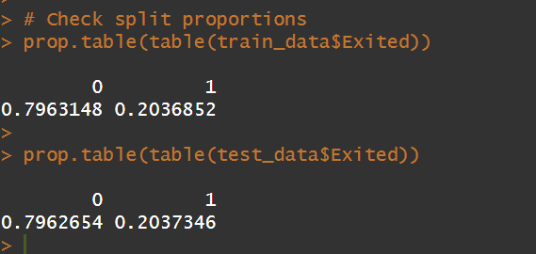
Interpretation: The train-test split successfully maintained similar churn proportions across both datasets, ensuring a balanced and representative evaluation process. Approximately 70% of the observations were allocated to the training dataset and 30% to the testing dataset. Preserving the original class distribution is particularly important in churn prediction because the dataset is imbalanced, with retained customers substantially outnumbering churned customers. Using a separate testing dataset allows the predictive performance of the logistic regression model to be evaluated objectively on unseen customer records, providing a more realistic estimate of real-world model performance.

3. Logistic Regression Model
The 70/30 stratified split maintained equal class proportions in both sets (Retained: 79.63%, Churned: 20.37%). The logistic regression model was fitted on the training data using all ten predictors.
Output — Significant Predictors:
Variable | Estimate | Std. Error | z value | p-value
GeographyGermany | 6.941e-01 | 8.047e-02 | 8.626 | < 2e-16 ***
GenderMale | -5.057e-01 | 6.468e-02 | -7.819 | 5.32e-15 ***
Age | 6.988e-02 | 3.032e-03 | 23.047 | < 2e-16 ***
Balance | 2.940e-06 | 6.063e-07 | 4.850 | 1.24e-06 ***
IsActiveMember1 | -1.107e+00 | 6.880e-02 | -16.095 | < 2e-16 ***
Tenure | -2.219e-02 | 1.120e-02 | -1.981 | 0.0476 *
Table 1. Logistic Regression Model Coefficients (Significant Predictors)
Interpretation: The model identifies five statistically significant predictors of customer churn at the 0.05 level: GeographyGermany, GenderMale, Age, Balance, IsActiveMember, and Tenure. The model achieves a meaningful reduction in deviance from 7,077.6 (null) to 6,062.4 (residual). Variables that do not reach significance, which are GeographySpain, NumOfProducts, HasCrCard, and EstimatedSalary, do not independently contribute to churn prediction when other variables are controlled for.

4. Multicollinearity Check (VIF)
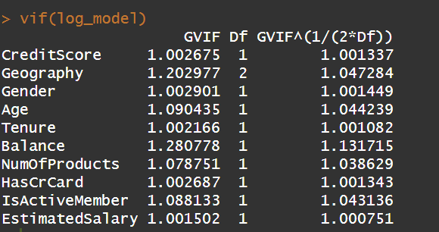
Interpretation: All Generalized VIF values range from 1.001 to 1.281, conclusively ruling out multicollinearity as a threat to the validity of the regression coefficients. Each predictor variable contributes independent information to the model, confirming that significant predictors can be interpreted individually with confidence.

5. Odds Ratios
Variable | Odds Ratio | Interpretation
Age | 1.072 | Each additional year increases churn odds by 7.2%
GeographyGermany | 2.002 | German customers have 2× higher churn odds than French
IsActiveMember1 | 0.330 | Active members have 67% lower churn odds
GenderMale | 0.603 | Male customers have 40% lower churn odds than females
Balance | 1.000 | Slight positive effect; each €1 increase marginally raises odds
Tenure | 0.978 | Each additional year reduces churn odds by ~2.2%
Table 2. Key Odds Ratios from Logistic Regression Model
Interpretation: The most impactful predictors are: (1) being an inactive member (OR = 0.330 for active status; inactivity nearly triples churn odds), (2) being located in Germany (OR = 2.002; doubling churn odds), (3) age (OR = 1.072 per year; compounding significantly over decades), and (4) being female (females face ~66% higher odds than males). Balance and tenure have statistically significant but practically small per-unit effects.

6. Variable Importance
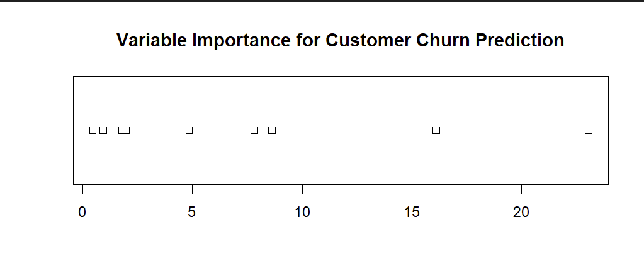
Figure 9. Variable Importance Rankings (Logistic Regression)
Variable | Importance Score
Age | 23.05
IsActiveMember1 | 16.10
GeographyGermany | 8.63
GenderMale | 7.82
Balance | 4.85
Tenure | 1.98
CreditScore | 1.78
NumOfProducts | 0.93
EstimatedSalary | 0.92
GeographySpain | 0.90
HasCrCard1 | 0.47
Table 3. Variable Importance Scores (Absolute z-statistics)
Interpretation: Age is the dominant predictor by a considerable margin (23.05), followed by IsActiveMember (16.10), GeographyGermany (8.63), and GenderMale (7.82). Balance and Tenure contribute moderately, while CreditScore, NumOfProducts, EstimatedSalary, GeographySpain, and HasCrCard contribute minimally. This ranking is consistent with the coefficient significance values and provides a clear priority order for business action.

7. Model Evaluation — Confusion Matrix (Threshold = 0.5)
Metric | Value
Overall Accuracy | 82.16%
Sensitivity (Churn Recall) | 23.08%
Specificity | 97.28%
Precision (PPV) | 68.45%
Balanced Accuracy | 60.18%
Kappa | 0.2702
Table 4. Confusion Matrix Metrics at Threshold = 0.5
Interpretation: At the default threshold of 0.5, the model achieves 82.16% overall accuracy but only 23.08% sensitivity for the churn class. In practical terms, the model misses 470 out of 611 actual churners in the test set. The low Kappa (0.2702) confirms that agreement beyond chance is modest. For a bank using this model to guide retention efforts, a sensitivity of 23% means the vast majority of at-risk customers would go undetected, highlighting the need for threshold adjustment or class-balancing techniques.

8. Threshold Tuning (Threshold = 0.3)
Metric | Threshold = 0.5 | Threshold = 0.3
Overall Accuracy | 82.16% | 79.23%
Sensitivity | 23.08% | 51.88%
Specificity | 97.28% | 86.22%
Balanced Accuracy | 60.18% | 69.05%
Kappa | 0.2702 | 0.3731
Table 5. Comparison of Threshold = 0.5 vs. Threshold = 0.3
Interpretation: Lowering the threshold from 0.5 to 0.3 nearly doubles sensitivity (23.1% to 51.9%), meaning the model now correctly identifies over half of actual churners. Balanced accuracy improves from 60.2% to 69.1% and Kappa from 0.2702 to 0.3731. The cost is an increase in false positives, which carries the manageable business cost of unnecessary retention outreach—a trade-off that is generally favorable in churn contexts, where missing a churner is far more costly than incorrectly targeting a loyal customer.

9. SMOTE Class Balancing and Re-Modelling
Post-SMOTE Training Distribution: Retained: 56.6% (n = 5,575) | Churned: 43.4% (n = 4,278) | Total: 9,853 observations
Metric | Baseline (T=0.5) | Tuned (T=0.3) | SMOTE + T=0.3
Overall Accuracy | 82.16% | 79.23% | 58.95%
Sensitivity (Recall) | 23.08% | 51.88% | 86.09%
Specificity | 97.28% | 86.22% | 52.01%
Precision (PPV) | 68.45% | 49.07% | 31.46%
Balanced Accuracy | 60.18% | 69.05% | 69.05%
Kappa | 0.2702 | 0.3731 | 0.2314
Table 6. Model Performance Comparison Across All Three Configurations
Interpretation: The SMOTE-enhanced model substantially improves sensitivity to 86.09%, correctly identifying 526 of 611 actual churners in the test set compared to only 141 identified by the baseline model. However, this improvement comes at the cost of significantly reduced specificity (52.01%) and overall accuracy (58.95%), indicating that the model over-predicts churn for many non-churners. Although balanced accuracy remains equal to the threshold-tuned model (69.05%), the lower precision and Kappa suggest reduced overall model stability. This approach may be appropriate in situations where maximizing churn detection is prioritized over operational efficiency and false positive control.

10. ROC Curve and AUC
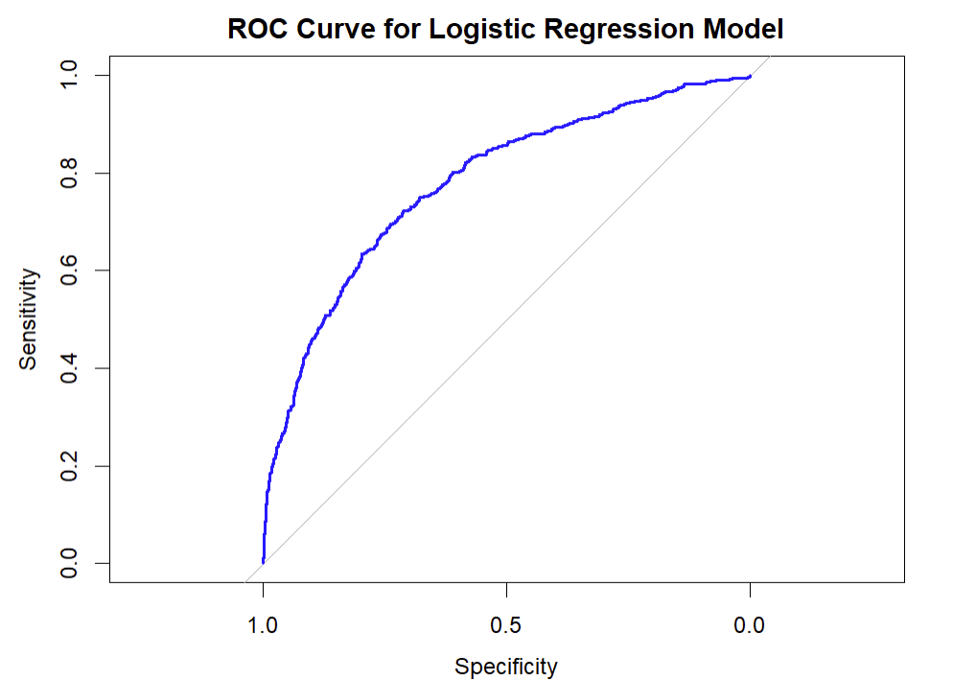
Figure 10. ROC Curve for Logistic Regression Model (AUC = 0.7796)
Interpretation: The ROC curve plots sensitivity against 1-specificity across all possible classification thresholds. The AUC of 0.7796 indicates good discriminatory ability: the model correctly ranks a randomly chosen churner above a randomly chosen non-churner approximately 78% of the time. An AUC between 0.7 and 0.8 is considered acceptable to good for real-world classification tasks (Hosmer et al., 2013). The curve rises steeply from the origin before leveling off, indicating meaningful sensitivity gains with relatively modest false positive rates in the optimal operating range.

Interpretation and Conclusions

Summary of Key Findings

The logistic regression analysis identified several statistically significant predictors of customer churn. Age emerged as one of the strongest predictors, with each additional year increasing churn odds by approximately 7.2% (OR = 1.072), suggesting that older customers may be more likely to seek alternative banking options or financial products. Customer activity status was also highly influential: inactive customers showed substantially higher churn risk, while active membership significantly reduced churn likelihood (OR = 0.330 for active status), highlighting the importance of customer engagement and relationship management.

Geography also played a major role in churn behavior. German customers were approximately twice as likely to churn compared to French customers (OR = 2.002), indicating potential regional or market-specific factors affecting customer retention. Female customers demonstrated moderately higher churn risk than male customers, while higher account balances and shorter tenure showed smaller but statistically significant effects on churn probability.

From a modeling perspective, the baseline logistic regression model achieved high overall accuracy (82.2%) but poor sensitivity (23.1%), indicating that many churners were missed at the default classification threshold. Lowering the classification threshold to 0.3 substantially improved sensitivity to 51.9% while maintaining acceptable overall model stability and balanced accuracy. Although the SMOTE-enhanced model achieved the highest sensitivity (86.1%), it also produced substantially lower specificity, precision, and overall accuracy, resulting in excessive false positives. Consequently, the threshold-tuned logistic regression model (0.30) was selected as the preferred approach because it provided the best balance between churn detection capability and operational practicality. The model’s AUC of 0.7796 further indicates good overall discriminatory ability for customer churn prediction.

Recommendations
- Deploy the threshold-tuned logistic regression model (threshold = 0.30) for customer churn prediction and retention targeting. This approach provides the best balance between churn detection, model stability, and operational efficiency while substantially improving sensitivity compared to the baseline model.
- Implement targeted re-engagement programs for inactive members. Since inactivity significantly increases churn risk, proactive outreach such as personalized offers, product recommendations, or account reviews may help reduce customer attrition.
- Develop age-sensitive retention strategies. Age emerged as one of the strongest predictors of churn; therefore, tailored communication, loyalty programs, and financial products should be considered for customers in higher-risk age groups.
- Investigate German market-specific churn drivers. The significantly higher churn risk among German customers suggests potential regional factors related to competition, customer expectations, or service experience that require further analysis.
- Develop gender-sensitive retention strategies. Female customers demonstrated moderately higher churn risk, indicating that differences in customer experience, communication preferences, or product alignment may warrant additional investigation.
- Continue enhancing the predictive model using additional behavioral variables such as transaction activity, digital banking engagement, customer satisfaction scores, and product usage metrics to improve predictive performance.
In conclusion, logistic regression provided an effective and interpretable framework for customer churn prediction. The threshold-tuned model (0.30) offered the most balanced predictive performance and operational practicality, making it the preferred approach for supporting proactive customer retention strategies.

References
Chawla, N. V., Bowyer, K. W., Hall, L. O., & Kegelmeyer, W. P. (2002). SMOTE: Synthetic minority over-sampling technique. Journal of Artificial Intelligence Research, 16, 321–357. https://doi.org/10.1613/jair.953
Hosmer, D. W., Lemeshow, S., & Sturdivant, R. X. (2013). Applied logistic regression (3rd ed.). Wiley.
Kuhn, M. (2008). Building predictive models in R using the caret package. Journal of Statistical Software, 28(5), 1–26. https://doi.org/10.18637/jss.v028.i05
Reichheld, F. F., & Schefter, P. (2000). E-loyalty: Your secret weapon on the web. Harvard Business Review, 78(4), 105–113.
Robin, X., Turck, N., Hainard, A., Tiberti, N., Lisacek, F., Sanchez, J.-C., & Müller, M. (2011). pROC: An open-source package for R and S+ to analyze and compare ROC curves. BMC Bioinformatics, 12, 77. https://doi.org/10.1186/1471-2105-12-77
R Core Team. (2026). R: A language and environment for statistical computing (Version 4.5.3). R Foundation for Statistical Computing. https://www.R-project.org/
Wei, T., & Simko, V. (2021). R package “corrplot”: Visualization of a correlation matrix (Version 0.92). https://github.com/taiyun/corrplot

Appendix A: Complete R Code
The following R script contains the complete code used in this analysis, organized by section.

A.1 Load Required Libraries
required_packages <- c("readxl","dplyr","caret","car","corrplot","pROC","smotefamily")
install_if_missing <- function(pkg) {
if (!require(pkg, character.only = TRUE)) {
install.packages(pkg, dependencies = TRUE)
}
library(pkg, character.only = TRUE)
}
lapply(required_packages, install_if_missing)

A.2 Data Import and Inspection
churn <- read_excel("churn.xlsx")
str(churn)
dim(churn)
colSums(is.na(churn))
sum(duplicated(churn))

A.3 Data Cleaning
churn <- churn %>%
mutate(
Geography = as.factor(Geography),
Gender = as.factor(Gender),
Exited = as.factor(Exited),
HasCrCard = as.factor(HasCrCard),
IsActiveMember = as.factor(IsActiveMember)
)
summary(churn)
str(churn)

A.4 Exploratory Data Analysis
# Churn distribution
table(churn$Exited)
prop.table(table(churn$Exited))
counts <- table(churn$Exited)
pct <- round(prop.table(counts) * 100, 1)
barplot(counts, col = c("skyblue","salmon"),
main = "Customer Churn Distribution",
names.arg = c("Stayed","Churned"),
xlab = "Customer Status", ylab = "Number of Customers")
text(x = c(0.7,1.9), y = counts, label = paste0(pct,"%"), pos = 3)

# Age vs Churn
boxplot(Age ~ Exited, data = churn,
col = c("skyblue","salmon"), names = c("Stayed","Churned"),
main = "Age Distribution by Churn Status",
xlab = "Customer Status", ylab = "Age")

# Balance vs Churn
boxplot(Balance ~ Exited, data = churn,
col = c("skyblue","salmon"), names = c("Stayed","Churned"),
main = "Account Balance by Churn Status",
xlab = "Customer Status", ylab = "Balance")

# Geography vs Churn
geo_churn <- prop.table(table(churn$Geography, churn$Exited), 1)
geo_churn_pct <- round(geo_churn * 100, 1)
geo_churn_pct
barplot(geo_churn[,2], col = "salmon", main = "Churn Rate by Geography",
xlab = "Geography", ylab = "Churn Rate",
ylim = c(0, max(geo_churn[,2]) * 1.2))
text(x = 1:3, y = geo_churn[,2], label = paste0(geo_churn_pct[,2],"%"), pos = 3)

# Activity Status vs Churn
active_churn <- prop.table(table(churn$IsActiveMember, churn$Exited), 1)
active_churn_pct <- round(active_churn * 100, 1)
barplot(active_churn[,2], col = "salmon", main = "Churn Rate by Activity Status",
names.arg = c("Inactive","Active"),
xlab = "Customer Activity Status", ylab = "Churn Rate",
ylim = c(0, max(active_churn[,2]) * 1.2))
text(x = 1:2, y = active_churn[,2], label = paste0(active_churn_pct[,2],"%"), pos = 3)

# Number of Products vs Churn
product_churn <- prop.table(table(churn$NumOfProducts, churn$Exited), 1)
product_churn_pct <- round(product_churn * 100, 1)
barplot(product_churn[,2], col = "orange",
main = "Churn Rate by Number of Products",
xlab = "Number of Products", ylab = "Churn Rate",
ylim = c(0, max(product_churn[,2]) * 1.2))
text(x = 1:nrow(product_churn), y = product_churn[,2],
label = paste0(product_churn_pct[,2],"%"), pos = 3)

# Correlation Matrix
numeric_vars <- churn %>%
select(CreditScore, Age, Tenure, Balance, NumOfProducts, EstimatedSalary)
cor_matrix <- cor(numeric_vars)
corrplot(cor_matrix, method = "color", type = "upper",
tl.col = "black", tl.srt = 45, addCoef.col = "black",
number.cex = 0.7,
col = colorRampPalette(c("red","white","blue"))(200))

# Age and Balance Scatter Plot
plot(churn$Age, churn$Balance,
col = ifelse(churn$Exited == "1","salmon","skyblue"),
pch = 16, xlab = "Age", ylab = "Balance",
main = "Age and Balance by Churn Status")
legend("topright", legend = c("Stayed","Churned"),
col = c("skyblue","salmon"), pch = 16)

A.5 Modeling
# Remove ID columns
churn_model <- churn %>% select(-RowNumber, -CustomerId, -Surname)

# Train/test split
set.seed(123)
train_index <- createDataPartition(churn_model$Exited, p = 0.70, list = FALSE)
train_data <- churn_model[train_index, ]
test_data <- churn_model[-train_index, ]

# Logistic Regression
log_model <- glm(Exited ~ CreditScore + Geography + Gender + Age +
Tenure + Balance + NumOfProducts + HasCrCard +
IsActiveMember + EstimatedSalary,
data = train_data, family = binomial)
summary(log_model)

# VIF
vif(log_model)

# Odds Ratios
round(exp(coef(log_model)), 3)

# Variable Importance
importance <- varImp(log_model)
importance
plot(importance)

# Predictions — Threshold 0.5
pred_prob <- predict(log_model, newdata = test_data, type = "response")
pred_class <- ifelse(pred_prob > 0.5, "1", "0")
pred_class <- factor(pred_class, levels = levels(test_data$Exited))
confusionMatrix(data = pred_class, reference = test_data$Exited, positive = "1")

# Predictions — Threshold 0.3
pred_class_03 <- ifelse(pred_prob > 0.3, "1", "0")
pred_class_03 <- factor(pred_class_03, levels = levels(test_data$Exited))
confusionMatrix(data = pred_class_03, reference = test_data$Exited, positive = "1")

# SMOTE
train_numeric <- as.data.frame(model.matrix(Exited ~ ., data = train_data)[,-1])
train_target <- as.factor(train_data$Exited)
smote_data <- SMOTE(X = train_numeric, target = train_target, K = 5, dup_size = 2)
train_smote <- smote_data$data
colnames(train_smote)[ncol(train_smote)] <- "Exited"
train_smote$Exited <- as.factor(train_smote$Exited)

# SMOTE Model
log_model_smote <- glm(Exited ~ ., data = train_smote, family = binomial)
summary(log_model_smote)

# SMOTE Predictions
test_numeric <- as.data.frame(model.matrix(Exited ~ ., data = test_data)[,-1])
pred_prob_smote <- predict(log_model_smote, newdata = test_numeric, type = "response")
pred_class_smote <- ifelse(pred_prob_smote > 0.3, "1", "0")
pred_class_smote <- factor(pred_class_smote, levels = levels(test_data$Exited))
confusionMatrix(data = pred_class_smote, reference = test_data$Exited, positive = "1")

# ROC Curve and AUC
roc_obj <- roc(test_data$Exited, pred_prob)
plot(roc_obj, col = "blue", main = "ROC Curve for Logistic Regression Model")
auc(roc_obj)

Appendix B: Dataset Summary Statistics
Table B1 presents descriptive statistics for all numeric variables in the dataset.
Variable | Min | Q1 | Median | Mean | Q3 | Max
CreditScore | 350 | 584 | 652 | 650.5 | 718 | 850
Age | 18 | 32 | 37 | 38.92 | 44 | 92
Tenure | 0 | 3 | 5 | 5.01 | 7 | 10
Balance | 0 | 0 | 97,199 | 76,486 | 127,644 | 250,898
NumOfProducts | 1 | 1 | 1 | 1.53 | 2 | 4
EstimatedSalary | 12 | 51,002 | 100,194 | 100,090 | 149,388 | 199,992
Table B1. Descriptive Statistics for Numeric Variables (N = 10,000)

Table B2 presents frequency distributions for all categorical variables.
Categorical Variable | Category | Frequency | Percentage
Geography | France | 5,014 | 50.1%
Geography | Germany | 2,509 | 25.1%
Geography | Spain | 2,477 | 24.8%
Gender | Female | 4,543 | 45.4%
Gender | Male | 5,457 | 54.6%
HasCrCard | No (0) | 2,945 | 29.5%
HasCrCard | Yes (1) | 7,055 | 70.6%
IsActiveMember | Inactive (0) | 4,849 | 48.5%
IsActiveMember | Active (1) | 5,151 | 51.5%
Exited (Outcome) | Retained (0) | 7,963 | 79.6%
Exited (Outcome) | Churned (1) | 2,037 | 20.4%
Table B2. Frequency Distribution of Categorical Variables (N = 10,000)

